Instructions on How to Change Your Office 365 Password

1. Navigate to [www.washoeschools.net](http://www.washoeschools.net)
2. Click on the “Students and Parents” tab

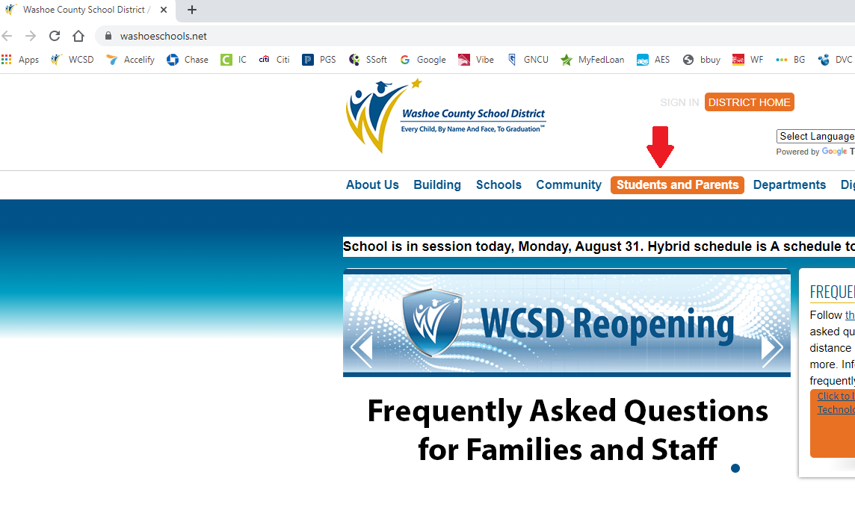

1. Click on “Office 365”

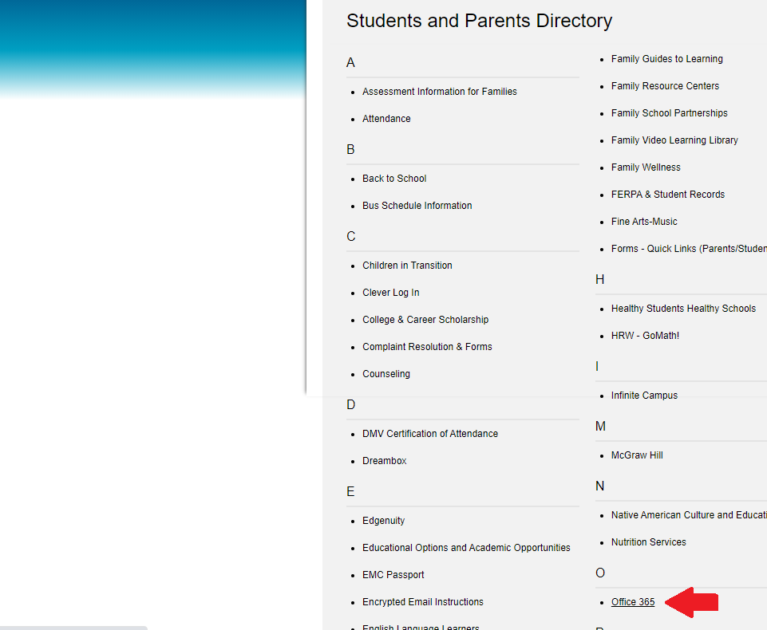

1. Click on the orange “Access Office 365” button

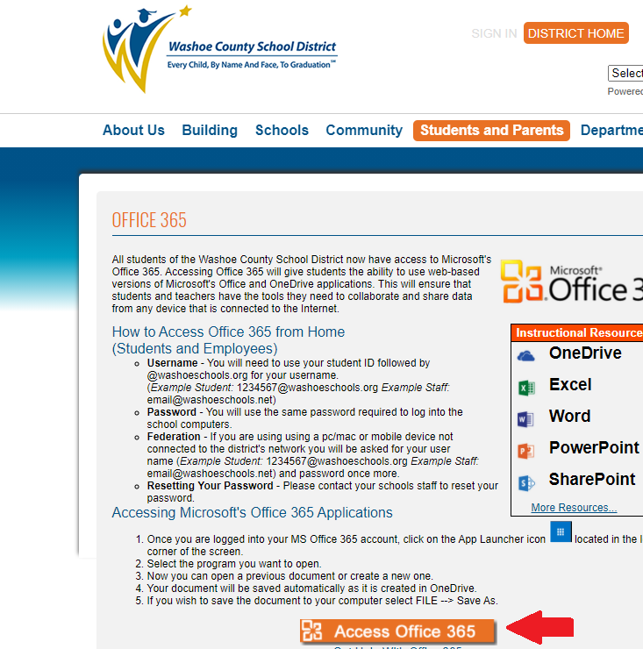

1. Click on the waffle in the upper left hand corner.

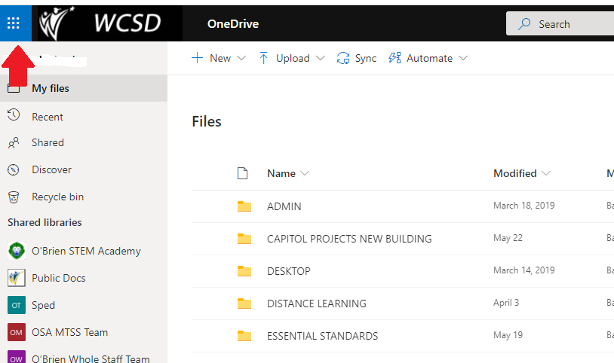

1. Click “Office 365”

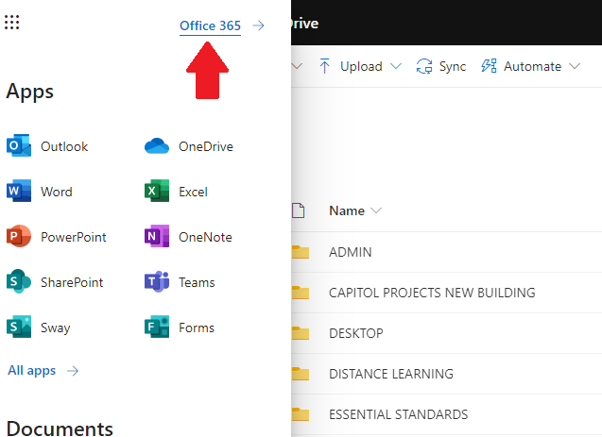

1. Click on this settings icon

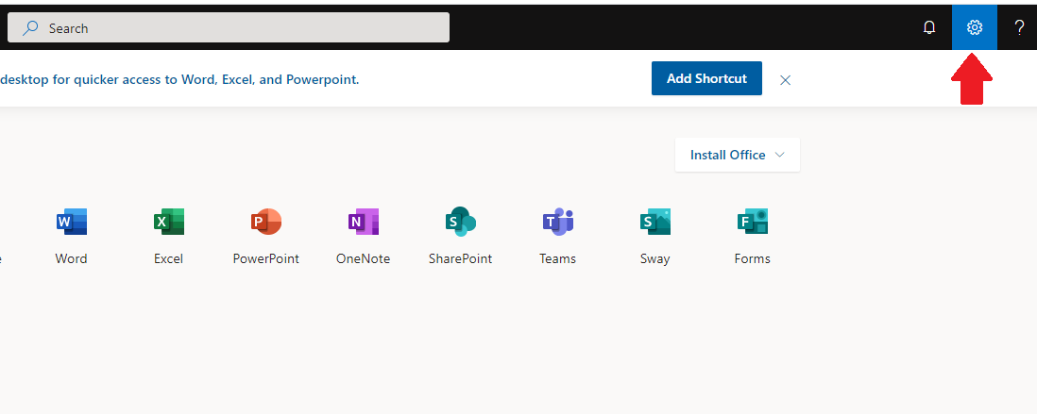

1. Click on the “Change your password” icon.

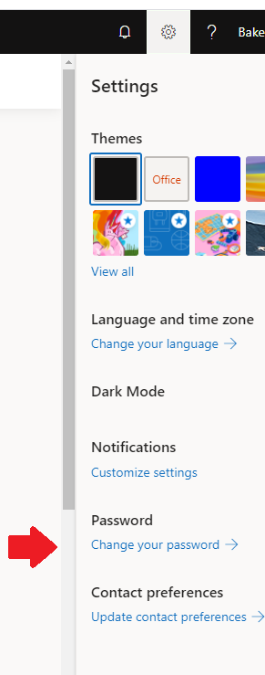

1. The student will be prompted to enter their existing password and then to create a new password. Once this password is changed, please utilize the new password to log into any WCSD issued device and please also use the new password to log into Office 365, Microsoft Teams, etc. Students with district issued devices may need to travel to a school parking lot to connect to district wifi in order for this password to successfully update. Please feel free to call 677-5420 if you have additional questions.